Six Can Competition
(rule version 1.01 – 20160921)

Objective: Six empty soda cans painted fluorescent orange will be placed in a walled playing field that resembles a soccer field. The judge will decide the location of the cans. Each end of the field will have a goal and a starting area. The challenge is to collect the cans and place them in the opposing goal as quickly as possible.

Robot: Competing robots must run autonomously, but are not required to be self-contained. Robot size is limited to less than 18x18 inches at the start of the competition. The robot may extend to a single footprint size of 21x18 inches, after moving outside the starting/goal area. These dimensions are chosen specifically to give competitors flexibility in the design of their robot base, and to specificity allow the use of iRobot Create/Roomba and Vex Clawbot type robots. Maximum robot weight is 35 pounds.

Self-Contained Definition: Self-contained means that all computing power used to run the robot is carried on the robot platform.

Run Definition: A run starts when the robot is placed in the starting area of the arena and given a signal from the judge. The run ends whenever the robot places 6 cans into the goal opposite of from its starting location or 10 minutes has elapsed. Each robot is allowed 1 run per contest round.

Round Definition: A round consists of a single run by each competing robot. The competition consists of 3 rounds.

Play: At the start of the competition, the robot's owner may place the robot anywhere in a start area. The robot may be turned to any angle when initially placed. Robots must fit in the starting area which is bounded by blue tape on 3 sides and the goal plane on the remaining side. This area is 18”x35”. The robot can be started at either of the goals.

A robot may only have control of one can at a time. Control is defined as changing the location of a can in a directed direction. An example of “control” would be a can in the robot’s gripper. An example of a can movement that is not in “control” would be a robot nudging a can, but then moving off. Changing a can location with an air stream or a kick or a projectile is considered
“controlling” the can.

If a robot is controlling more than one can at a time, the judge will immediately remove the additional cans from control and place them in a location of his choice. If a force causes multiple cans to be controlled, but one can was controlled before the others, all cans but the first directed can will be returned to a position of the judge’s decision. If multiple cans become controlled at the same time with no one can being clearly controlled before the others (as determined by the judge) all cans will be returned to a position of the judge’s decision.

A competitor may call for a reset during a round. When a reset is called the robot is returned to the starting area and the competitor is allowed to re-initialize the robot. A scoring penalty is subtracted from the robot’s round score for each reset (see scoring). An example where a reset may be required is when the robot appears trapped in a corner or against a wall. The run's timer will continue to run when a reset is process.

Competitors are allowed to setup beacons or other navigational aids outside of the walled area along the longer sides of the field, but not in the shorter side of the field or the area near or at the goals.
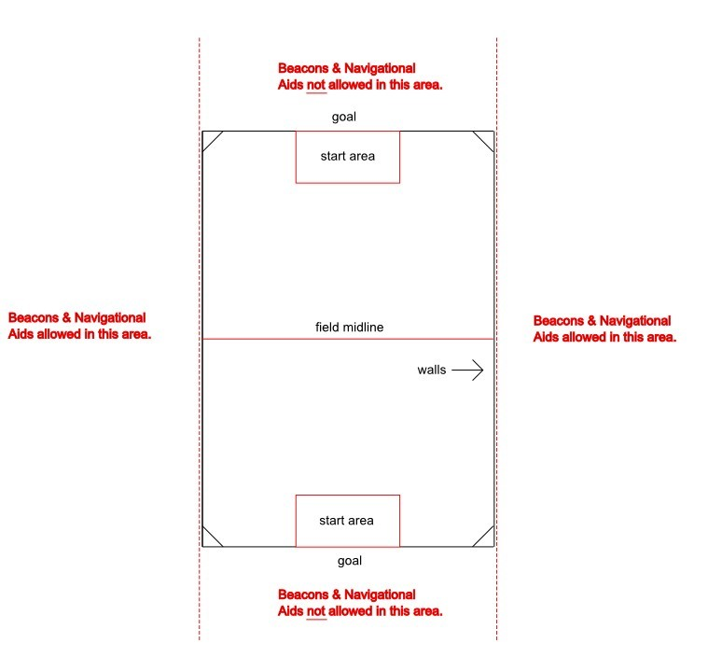

Course: The course size is 7x10 feet. The course surface will be the flooring of the room used for the competition, or such temporary material as is needed to protect that floor as deemed necessary by contest organizers and venue operators. This material could include wood, Tyvek, low-pile carpet, dense foam or other common flooring materials. The outline of the course will have walls of approximately 8 inches in height except where the goals are located. The color of the walls is white. The goals will be 35 inches wide and have a crossbar located at a height of 12 inches. The starting area is located in front of the goal extending 18 inches into the field. It will be outlined with ¾ inch blue masking tape. Blue masking tape will also be used to mark the middle of the field. Robots are placed in the starting/goal area at the start of the competition and whenever the robot is reset.
Six Can Arena Diagram
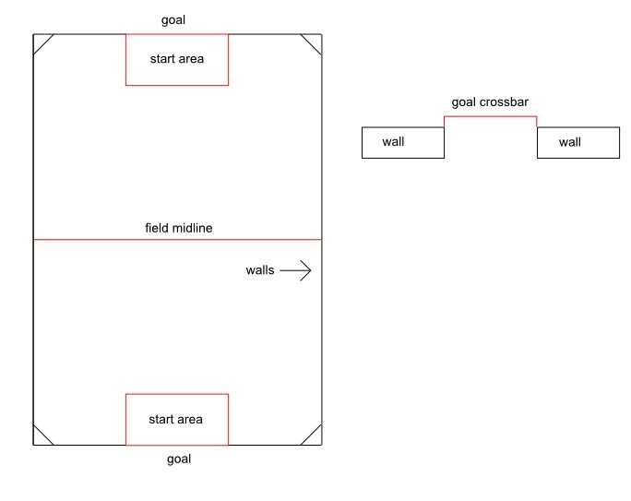
Cans: The cans are standard 12 ounce aluminum soda cans that are primed with white spray paint (Rust-oleum Professional Aluminum Primer – SKU 0 20066 19717 9 or Rust-oleum Painter’ touch - SKU 0 20066 18715 6) then painted with Rust-oleum specialty fluorescent orange spray paint (SKU 0 20066 19548 9). Before painting, the can’s pull tab is removed and the top of the can may be covered with a card stock circle painted insert (for appearances – not required). Currently both paints are available at Home Depot.

Can Placement: The judge will select locations for the cans just before the contest. No robot may enter the course once the can locations are selected except to compete. This is to prevent pre-event mapping of the can locations. Cans locations must be at least 5 inches from the walls of the arena. The judge may alter the can locations between each round of the competition.

Scoring: A robot’s run score is the sum of three components: number of cans scored, time required to complete the task, and the number of resets. A point is scored for every can that passes through the opposite goal from where the robot starts. The time component is scored using the equation time_score = 10 – time_taken. A negative point is scored for every reset requested by the competitor.

For example if a robot completed the task of moving all 6 cans to the opposing goal in 4 minutes 45 seconds and had one reset , the robot’s score would be 6 + (10 - 4.75) - 1 = 10.25. Another example would be a robot that only moved 5 cans to the goal in the 10 minutes of the round and had no resets. This robot’s score would be 5 + (10 - 10) - 0 = 5.

The winning robot is determined by comparing the best run scores of each robot.

Judging: One or more judges will referee the contest. They will ensure the rules are followed and impose scoring penalties or remove a robot from competition if the robot is operating in an unsafe manner or not complying with the rules. The decisions of the judges are final.

Safety: If the behavior of a robot is determined to be unsafe, the judge will withdraw the robot from the competition. Since pushing or “launching” cans is a legitimate strategy, the robot builder must take responsibility for limiting this ability so as not to create a safety hazard. The decisions of the judges regarding safety matters are final.

Picture of Six Can Arena
